
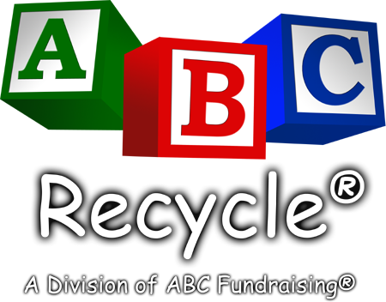
www.abcrecycle.com

Save On Taxes.
Save The Environment.
Help Our Organization.
Donate Your Used
Cell Phone & Printer or Toner Cartridges!

Dear Parent or Guardian:

(Insert your organization name here) is conducting a cell phone & ink jet recycling fundraiser. There’s nothing to buy. We are simply asking you to protect the environment by donating your used digital cell phone(s) and ink jet cartridge(s). Your used cell phone(s) may be tax deductible and will be recycled in accordance with EPA regulations or refurbished and sold. 100% of the proceeds will help fund (insert your organization’s cause here).

We greatly appreciate your support!

Best regards,

(Organization Name)
(Contact Name) / (Contact Phone #)

Please acknowledge that you have reviewed the material by checking one of the boxes below, initialing and having your child return the form to their teacher at school. Thank you.

Yes, I pledge my support by donating my used cell phone(s).
Note: We cannot accept accessories such as car chargers, ear-pieces, etc. Thank you.

I am unable to help at this time.

________________
Parent or Guardian’s Initials

(Tear along dotted line and retain for your records)

Tax Deductible Donation Acknowledgement

Thank you for donating your cellular phone(s). We cannot make any determination as to the value of the specific phone(s) you have donated to us. Generally speaking, older analog phones will not warrant a tax deduction (but still can be recycled). You should consult your tax advisor regarding value determination for tax purposes. The IRS requires the following information for tax deductions of $250 or less. Please fill in the information indicated below and retain this record for your tax records.

(Insert organization name here) _________ _______________________
Donation Organization Donation Date Description of phone(s)

_______ $__________ _________ _______________________
# of Phones Value of Donation Donor’s Name Donor’s Address

