
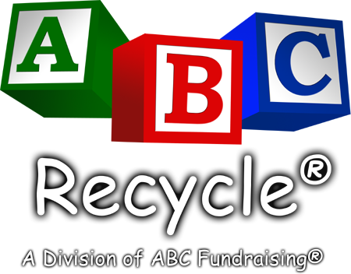
www.abcrecycle.com

Save On Taxes.
Save The Environment.
Help Our Organization.
Donate Your Used
Cell Phone & Printer or Toner Cartridges!

Hello neighbor:

(Insert your organization name here) is conducting a cell phone & ink jet recycling fundraiser. There’s nothing to buy. We are simply asking you to protect the environment by donating your used digital cell phone(s) and ink jet cartridge(s). Your used cell phone(s) may be tax deductible and will be recycled in accordance with EPA regulations or refurbished and sold. 100% of the proceeds will help fund (insert your organization’s cause here).

We greatly appreciate your support!

Best regards,

(Organization Name)
(Contact Name) / (Contact Phone #)

We will be back on (insert a date here) to collect your used cell phones and printer/toner cartridges. Your donation is greatly appreciated and will help our group tremendously.
Please leave your phones and cartridges by the front door in a bag on (insert a date here) and we will be by to pick them up.
Your donation may also be tax deductible. See below for details.

(Tear along dotted line and retain for your records)

Tax Deductible Donation Acknowledgement

Thank you for donating your cellular phone(s). We cannot make any determination as to the value of the specific phone(s) you have donated to us. Generally speaking, older analog phones will not warrant a tax deduction (but still can be recycled). You should consult your tax advisor regarding value determination for tax purposes and to confirm that this is an allowable deduction. The IRS requires the following information for tax deductions of $250 or less. Please fill in the information indicated below and retain this record for your tax records.

(Insert organization name here) _________ _______________________
Donation Organization Donation Date Description of phone(s)

_______ $__________ _________ _______________________
# of Phones Value of Donation Donor’s Name Donor’s Address

